Tivoli/tsm/baclient/dsmadmc' -id=userid -pa=password -tcps=adsmserver -tcpp=1500 -DISPLaymode=LISt q system

./tsmdiag –id tsmadmin –pa pwd4u –results /home/tsmdiag/results

export PATH=$PATH:/path/to/dir

echo PATH
____________________________________________________________________________
TSM Server Installation:

TSM Server 5.5:
Download TSM servcer from IBM FTP site:
http://ftp.software.ibm.com/storage/tivoli-storage-management/

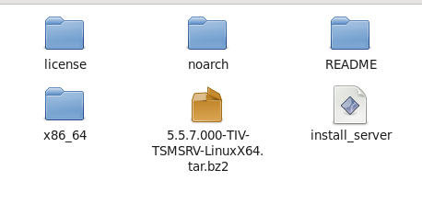
6.X

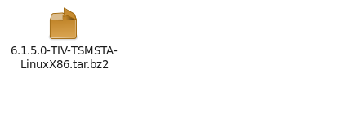
Extract tar file
I have copied this file to below directory and extracting
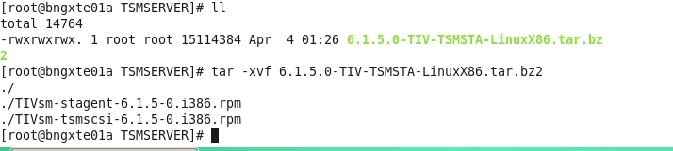

Tar –xvf 5.5.7.000-TIV-TSMSRV-Linuxx64.tar.bz2

You will get an rpm file then try to install that
Rpm –ivh tsm.rpm file
Install server
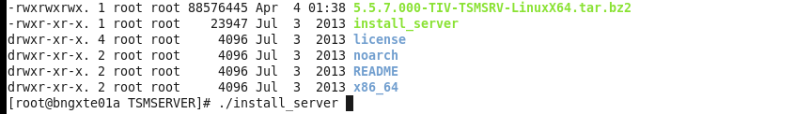
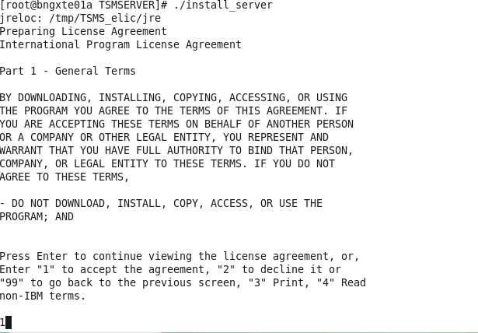

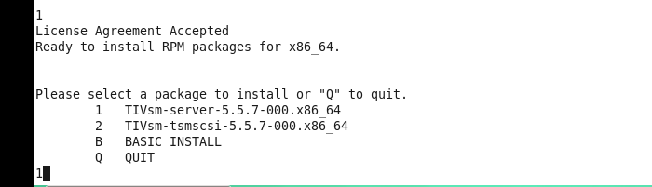
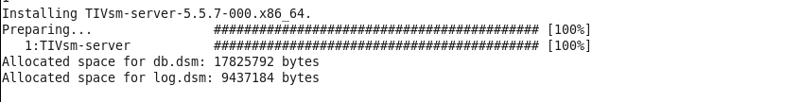

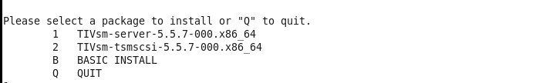
Enter Q to quit

Go to server path
Cd /opt/tivoli/tsm/server/bin/
./dsmserv
Q sys
Change server and ip name of the server
Set servername tsmserver1
Set serverhla 192.168.152.129

Halt

Try to copy dsmserv.rc to /etc/init.d/rc.dsmserv by which which can start the dsmserv command from any location
We can alos change the run levels of this file by chkconfig (make run levels 3 and 5 )
Cd /opt/tivoli/tsm/server/bin/
Cp –p dsmserv.rc /etc/init.d/rc.dsmserv

While starting dsmserv if we get any error with library access do the following things so that dsmserv can get access to libraries and can execute the command successfully

Copy libraries file as below to /usr/lib/
We can check the libraries than are needed by the binary as below
Ldd /opt/Tivoli/tsm/server/bin/tsmdiag/dsmserv
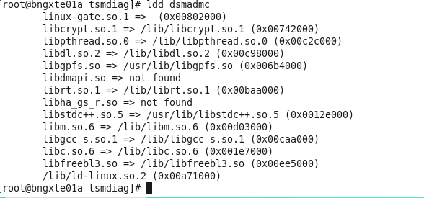
So here libdmapi.so is not found so try to copy this file from tsm bnary location

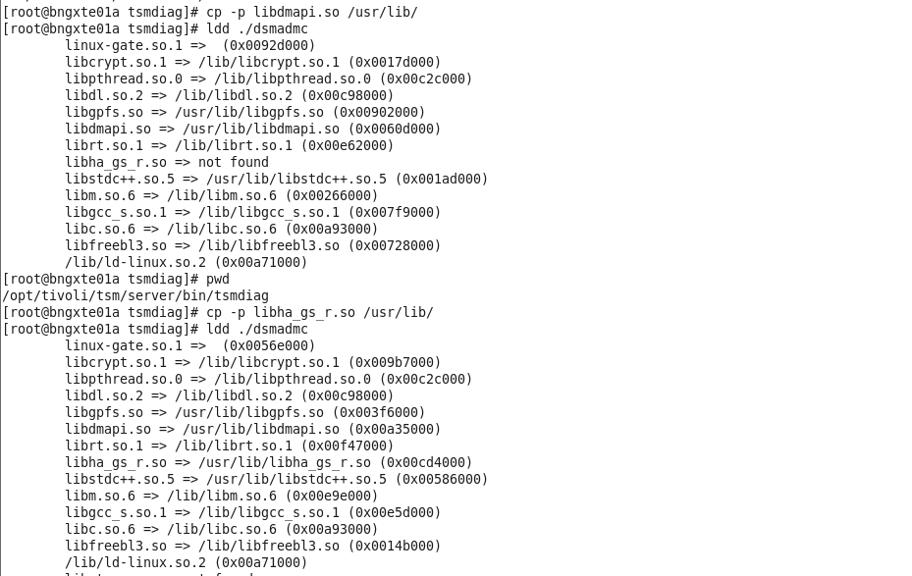

Another error while starting server

Installing TSM Server 6.3
After you will getting below files
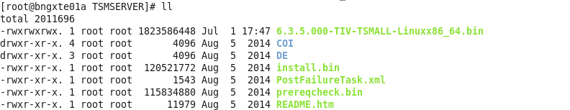

rpm -qi libgcc.i686 | grep Version

./prereqcheck.bin

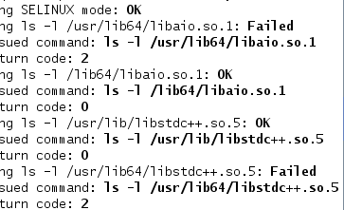
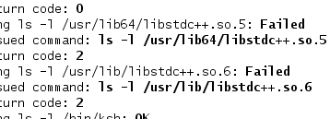

Try to install these libraries
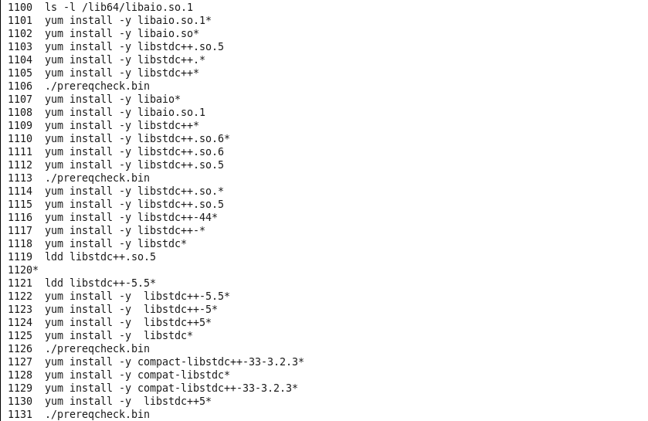

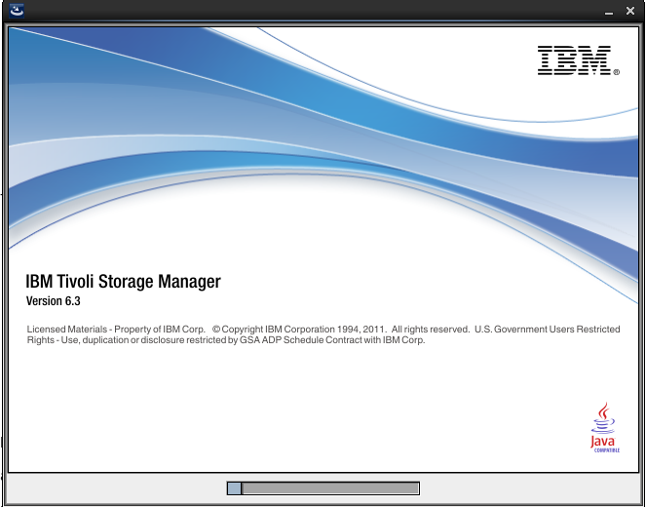
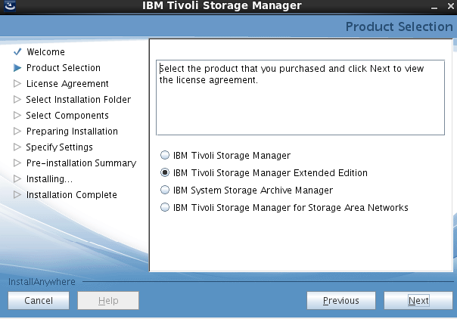
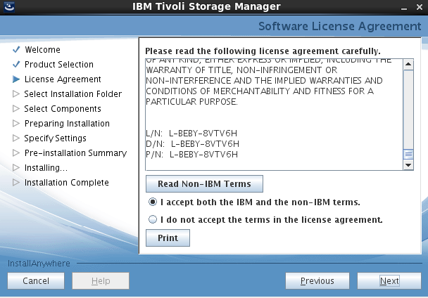
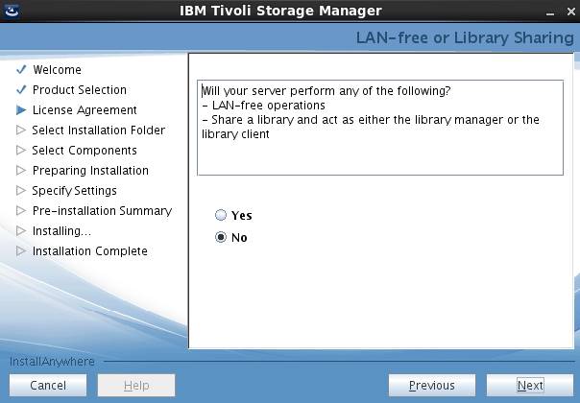
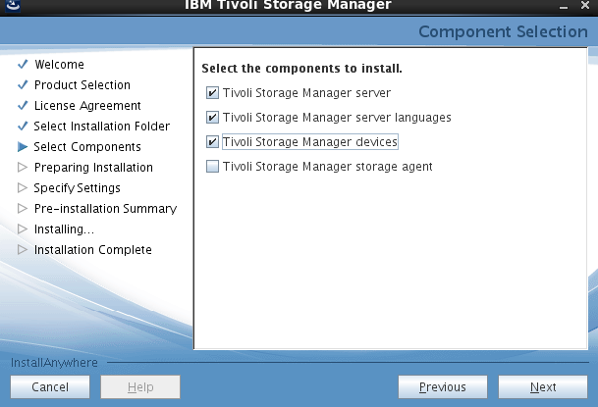
Select english
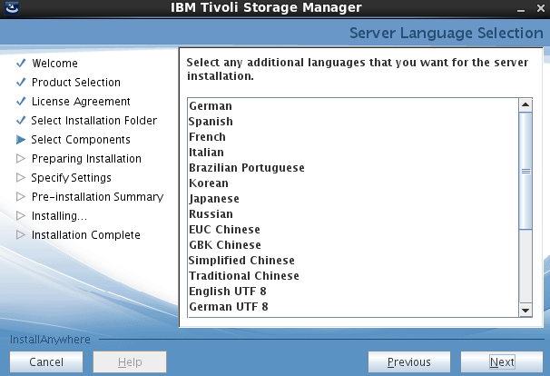
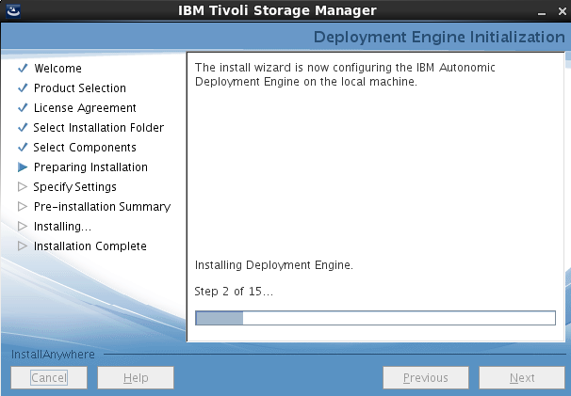
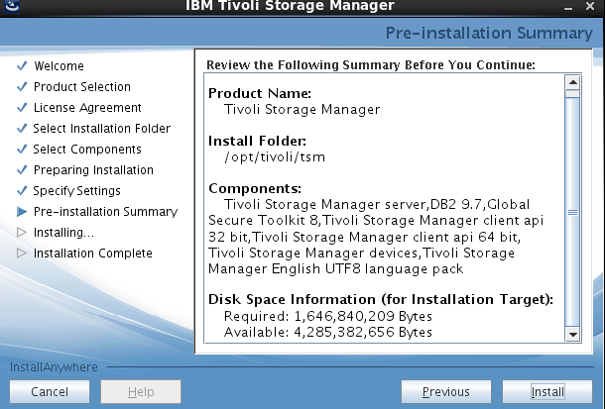
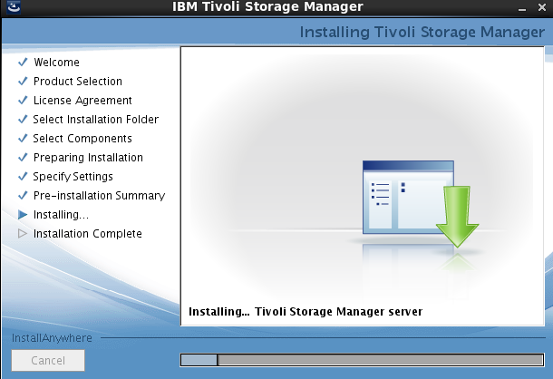
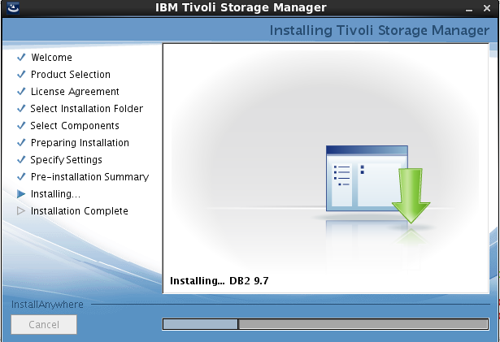
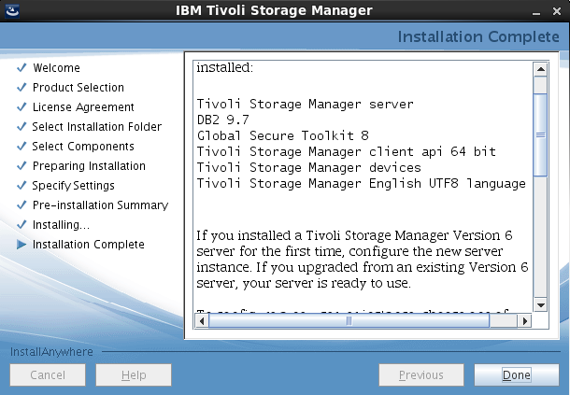
Starting server instance
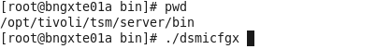
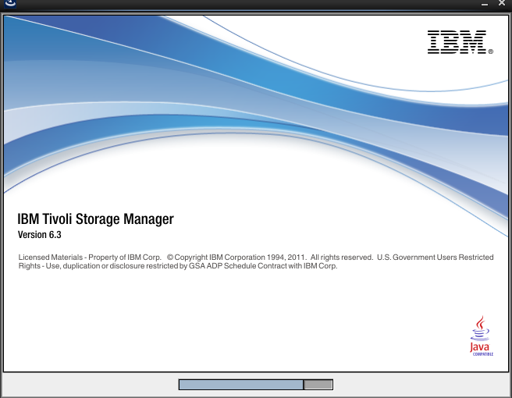
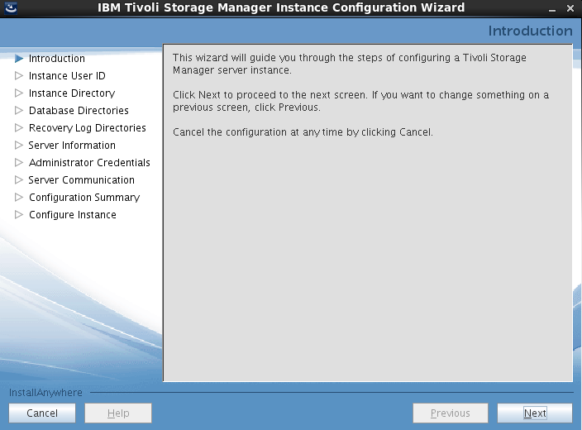

rpm -qi libgcc.i686 | grep Version

rpm -qi libgcc.i686 | grep Version

